**HAZARDOUS AREA MONITORING FOR INDUSTRIAL PLANTS POWERED BY IOT**

**SUBMITTED BY**

**TEAM ID:****PNT2022TMID41407**

MEENA S (620319106035)

GAYATHRI S (620319106023)

MOULISHA R (620319106037)

RITHIKA B (620319106047)

**BACHELOR OF ENGINEERING IN ELECTRONICS AND COMMUNICATION ENGINEERING**

**PROJECT DESIGN PHASE-II**

**TECHNOLOGY STACK (ARCHITECTURE & STACK)**

**Technical Architecture:**

The Deliverable shall include the architectural diagram as below and the information as per the table1 & table 2

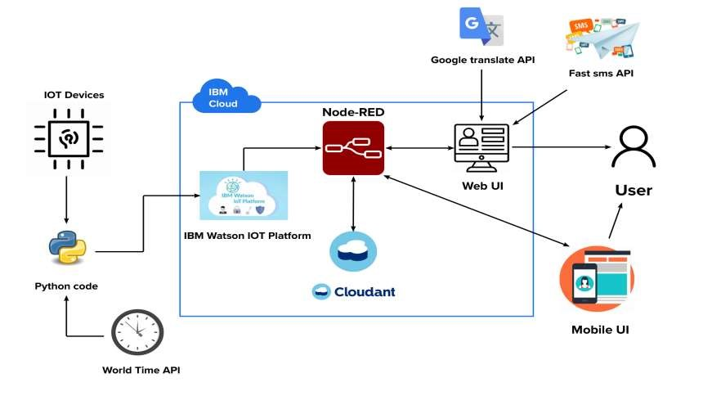

**Table-1 : Components & Technologies:**

|  |  |  |  |
| --- | --- | --- | --- |
| **S.No** | **Component** | **Description** | **Technology** |
| 1. | User Interface | Web UI, Mobile App, SMS service and Wearable devices | Node-RED, Fast SMS and MIT App inventor |
| 2. | Application Logic-1 | Getting input from smart beacons | Embedded C and Python |
| 3. | Application Logic-2 | Process data in cloud | IBM Watson IOT platform, Cloud-ant DB and Node-RED |
| 4. | Application Logic-3 | Display data to the user | Web UI, Fast SMS and Mobile application |
| 5. | Database | Real time database | Cloud-ant DB |
| 6. | Cloud Database | Database Service on Cloud | IBM Cloud-ant |
| 7. | Smart beacon | To monitor the area and update the stats in the cloud | Node MCU and Sensors |
| 8. | External API-1 | To send SMS to user | Fast SMS API |
| 9. | External API-2 | Language for the website is written to be dynamic | Google translate API |
| 10. | External API-3 | To access time | World time API |
| 11. | Infrastructure (Server / Cloud) | Application Deployment on Cloud | IBM Cloud |

**Table-2: Application Characteristics:**

|  |  |  |  |
| --- | --- | --- | --- |
| **S.No** | **Characteristics** | **Description** | **Technology** |
| 1. | Open-Source Frameworks | The Node-RED open-source frameworks are used to build the web application as well as to communicate with the mobile  application and to handle alert  SMS | Node-RED framework |
| 2. | Scalable Architecture | The 3 – tier architecture used with a separate user interface,  application tier and data tier makes  it easily scalable | IBM wat-son studio |
| 3. | Availability | The web application is highly available as it is deployed in cloud | IBM cloud |
| 4. | Performance | The performance of the website is improved with caching and security | IBM cloud internet services |